EXPERIMENT NO - 5
Name: Iqra Shaikh
Roll no:24DCO06
Batch:01

Aim: Case study on Telnet

Theory: Telnet
Telnet, which stands for Teletype Network, is a networking protocol and command-line interface used to provide a two-way, interactive text-based communication channel between two hosts on a network. It enables a user to log in to a remote computer (server) and execute commands as if they were physically present at the remote machine. It operates on TCP port 23.
Originally developed in 1969, Telnet was one of the first protocols for remote access, but its use has significantly declined due to a major security vulnerability: it transmits data, including usernames and passwords, in plain text. This lack of encryption makes it highly susceptible to eavesdropping and man-in-the-middle attacks

Advantages of Telnet
- Simplicity and Ease of Use: Its text-based nature makes it straightforward to use for basic remote management tasks.
- Universally Supported: Most network devices and operating systems still support Telnet,
- Low Overhead: The protocol is lightweight and requires minimal bandwidth, which can be useful in low-speed or resource-constrained environments.

Disadvantages of Telnet
- Lack of Security: The most significant drawback is that all data is transmitted in plain text, making it highly vulnerable to snooping.
- No Authentication: Telnet offers very weak authentication mechanisms, making it easy for attackers to compromise systems.
- No Encryption: It provides no security features, which is why it has been largely replaced by secure alternatives like SSH.

Telnet Client
A Telnet client is a software application that allows a user to initiate a connection to a remote server using the Telnet protocol. Most modern operating systems have a built-in Telnet client, but it is often disabled by default for security reasons. Users can enable the client via a command-line command or through the system's "Turn Windows features on or off" settings. The basic command syntax is typically telnet <hostname> <port>.
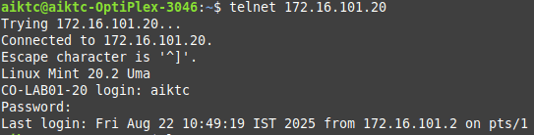

Conclusion
In conclusion, the Telnet protocol is a fundamental but now largely obsolete tool for remote network management. While its simplicity and universal compatibility made it a valuable asset in the early days of networking, its critical lack of security, specifically the transmission of unencrypted data, has rendered it unsuitable for modern applications. The rise of more secure and robust protocols like SSH (Secure Shell) has effectively replaced Telnet for all tasks requiring a secure and private connection, highlighting the importance of data encryption in today's interconnected world.

